Objective:
Purpose of Service Desk Manager is to create CA packages under specific application code. Application codes are alphanumeric four (4) digit assigned to applications.
ClientLink : Q700
FlexPak : UTS0
PRSNet : NB00
Holdco : YNU0

Packages are used to check-out and check in the source code as well as for the release purpose. Common services team uses the package/Release Notes to deploy the source code on respective environment. Packages are created either for Builds or Data Patches.

There are different flavours of Data Patches within ClientLink.
- Single Use Data Patch (SUDP) Ex:CO#10068
- ReRunable Data Patch (RRDP) Ex:CO#9507
- Rubber Stamp Root Data Patch (RSRootDP) Ex:CO#5145
- Rubber Stamp Data Patch (RSDP). This will be derived only if there is a RSRootDP . Ex:CO#9330
Note: CO is abbreviated for Change Order

Parent Change Order: This is the root change order that has been created for the first time. Subsequent changes order needs to be referenced to the root/parent change order. For DP’s parent change order is 1351 and 927 is for builds.

Order Summary Name: This refers to the package name and it consists of four parts.
- Build/DP number
- CA change order number (current and NOT the parent change order)
- Application code
- Short meaningful description of the PTR/SCR

Example:
- For DP: DPX2014-0092_CA010367_Q700_RSRootReOpenTask
- For Build: 60ER_CA010164_Q700_BPE_Adjust_repositories_access

URL for CA Service Desk Manager:

http://rbcsdm.fg.rbc.com:8001/CAisd/pdmweb.exe

Step1: Login to Service Desk Manager using LAN ID and password.

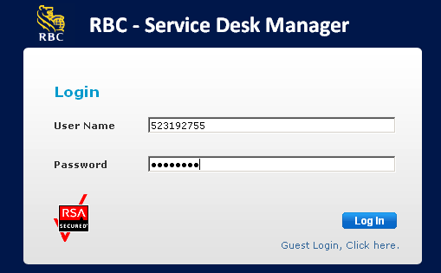

Step2: Enter the Change Order as referenced in Data Patch section and then click on Go button.

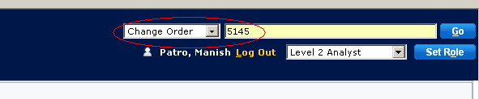

Step3: New windows open up with the details related to search changed order. In this case it is 5145. Click on File, drop down appears and then click on Copy . This will clone the details for the new change order.

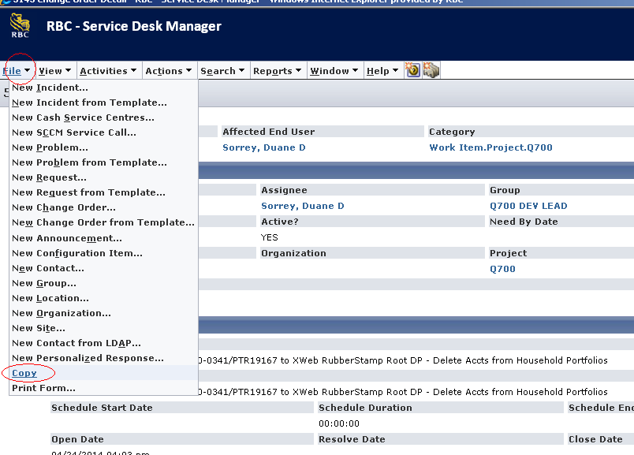

Step4: Complete the form by entering the details and then click Save.
- Requester
- Order Summary Name
- Parent Change Order

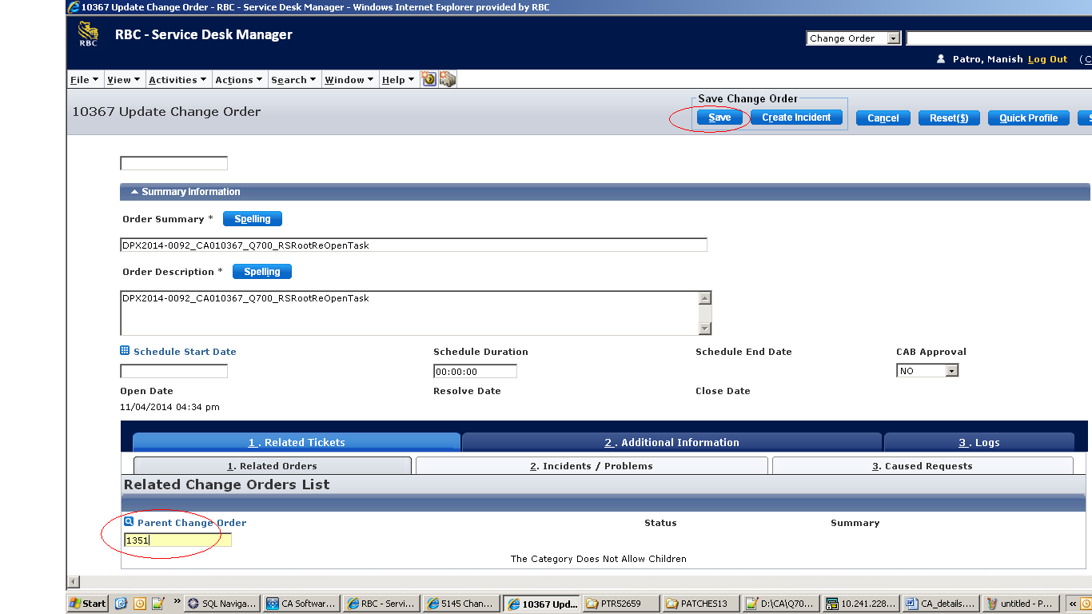

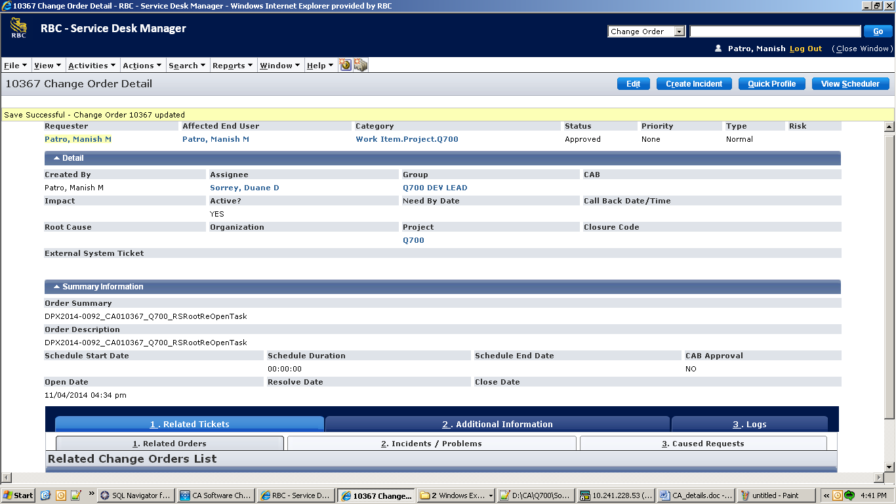

Step5: Click on Additional Information tab and then Workflow Task

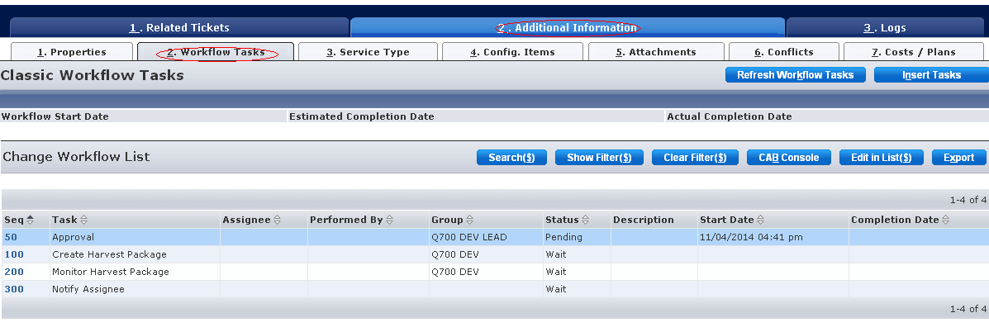

Step6: Under the Seq tab click on 50 and a new window opens

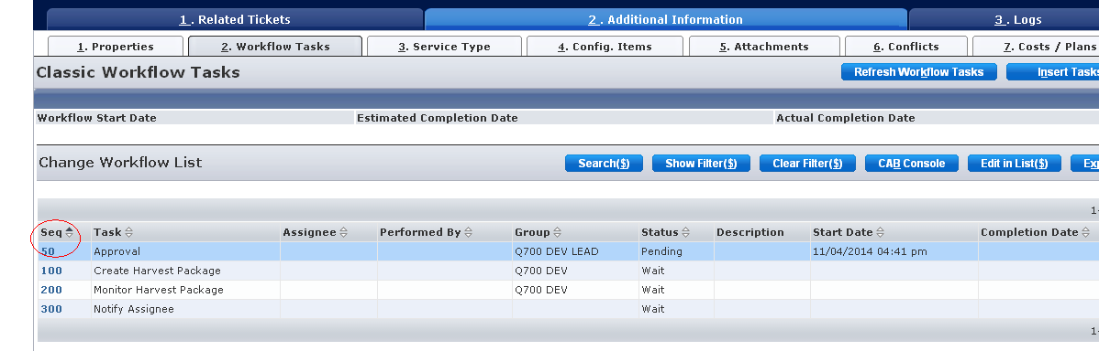

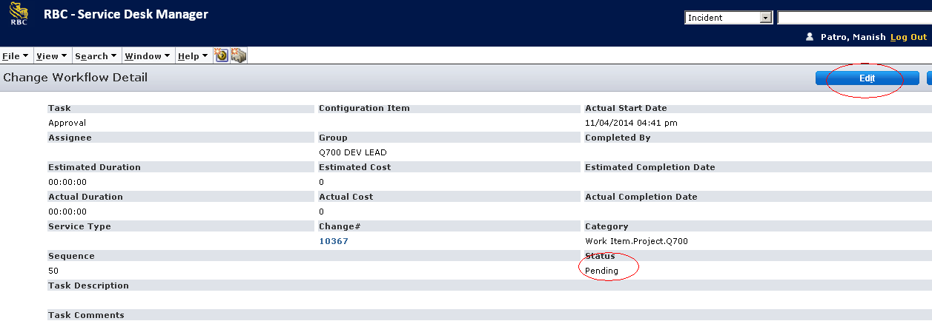

Step7: Click on Edit button, change the status to Approve and click Save button.

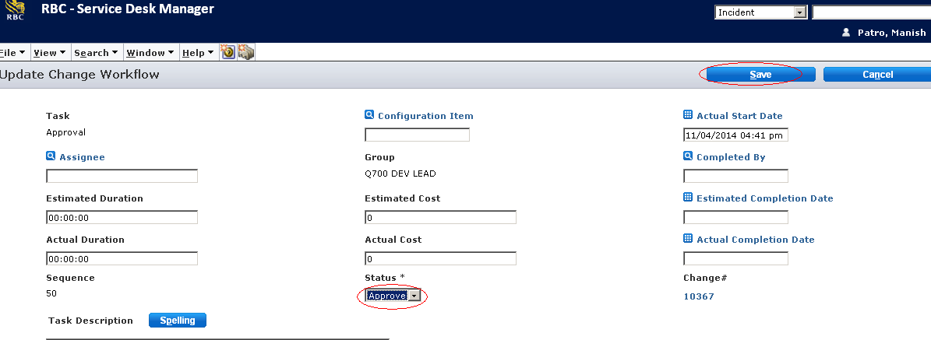

After successful message, click Close Window.

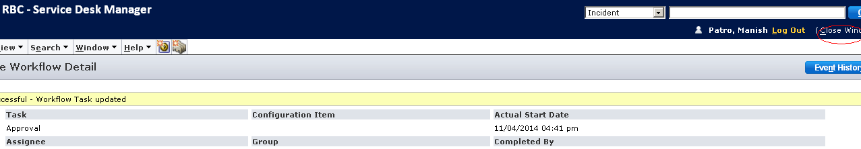

Step8: Refresh the page after 5-10 mins so the status of the package is changed to Completed.

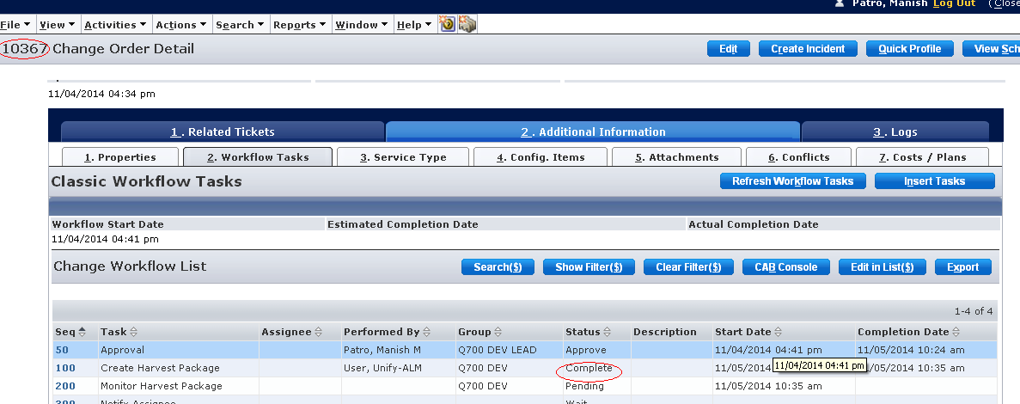

Step9: Check in CA work bench under the respective application code if the package has been created under the view Development.

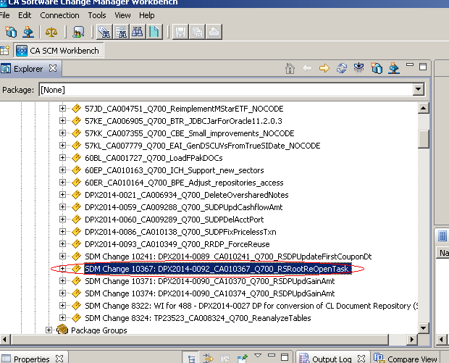

Step10: Rename the package

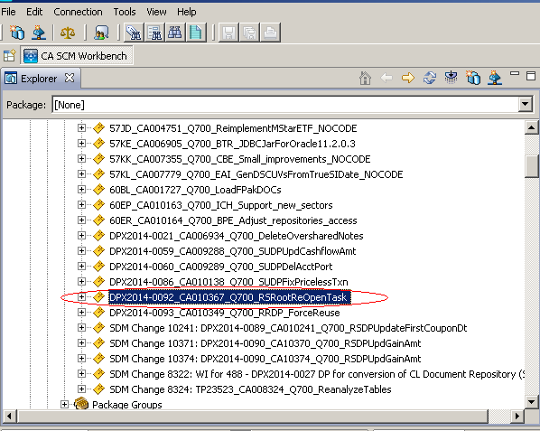

To update a script:
Demote to dev
Create a “checkout” directory in PTRXXX
Select scripts
Select “Checkout for update”
Choose the path to the “checkout” directory
Select Replace Writable option
Select OK
Download new files to the same directory where the older version was checked out.
To check in just select the files (from the same place) -> select check in option

